**Systematic Review**

**Research Questions:**

**RQ1:** What is the traditional bug classification and identification process?

**RQ4:** What kind of techniques has been proposed in past for classification and identification of bugs from gaming reviews?

**RQ2:** What evaluation/classification/identification metrics have been used?

**RQ3:** What are gamers talking about in gaming reviews?

**RQ5:** What is the overall research productivity in this domain?

**Data sources:**

Five electronic databases were considered as primary data sources for potentially relevant studies. Google Scholar was not included in the list due to low precision results and overlapping of results from other data sources.

|  |  |  |
| --- | --- | --- |
| **Identifier** | **Database** | **URL** |
| **ED1** | ACM | http://dl.acm.org/ |
| **ED2** | IEEE | http://ieeexplore.ieee.org/ |
| **ED3** | Science Direct | http://sciencedirect.com/ |
| **ED4** | Springer Link | http://link.springer.com/ |
| **ED5** | Wiley | http://onlinelibrary.wiley.com/ |

**Search Terms:**

Search terms are used in different combination to get the relevant research in this domain. Search terms were combined using conjunction (AND) and disjunction (OR) operator. The finalized search string for automated search is given below:

**(((gam* AND (bug OR defect OR fault) AND (identif* OR classif* OR analy*)))**

|  |  |  |
| --- | --- | --- |
| **Electronic databases** | **Query** | **Results** |
| **ACM** | [[[Title: game] AND [Title: identi*]] OR [Title: classif*]] AND [[Abstract: bug] OR [Abstract: defect] OR [Abstract: fault]] AND [Publication Date: (01/01/2011 TO 11/30/2021)] | 100 |
| **IEEE** | ((gam* AND ("Abstract":bug OR "Abstract":defect OR "Abstract":fault) AND (identif* OR classif* OR analy*)))  Filters Applied:  ConferencesJournals  2011 - 2021 | 366 |
| **Wiley** | "Game AND identi* OR classif*" in Title and "bug OR defect OR fault" in Abstract | 10 |
| **Science Direct** | Year: 2011-2021  Title, abstract, keywords: ((game AND bug OR defect OR fault) AND(Identification OR Classfication) | 46 |
| **Springer** | Query:  (Automated AND Bug AND identification AND with AND through AND early AND access AND game AND review AND analytics AND on AND game AND distribution AND platforms)  with content type article and discipline computer science | 33 |
|  |  | **TOTAL: 555** |

**Study selection procedure:**

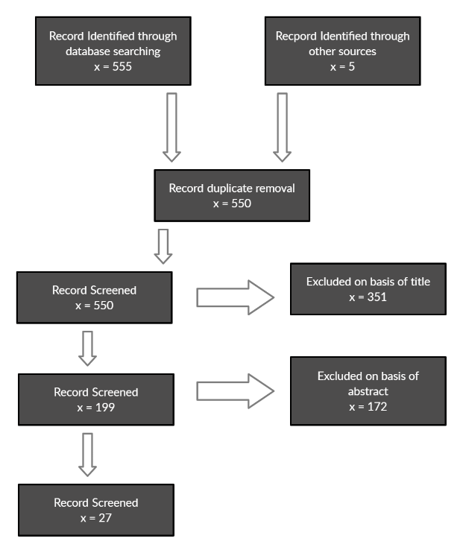

**Inclusion and exclusion criteria:**

* **Inclusion criteria:**

**IC1:** Articles that are peer reviewed

**IC2:** Articles introducing any procedures/techniques software bug categorization

**IC3:** Inclusion of most recent article in case of multiple studies on same theme

**IC4:** Inclusion of articles from 2011 to 2021

**IC5:** Articles related to the study of bug classification and categorization techniques

* **Exclusion criteria:**

**EC1:** Studies other than English language

**EC2:** Articles of bug/defect other than software domain

**EC3:** Studies with no validation of proposed techniques or validation solely through expert opinion

**EC4:** Articles providing unclear results or findings

**EC5:** Articles with no full text.

**EC6:** Articles other than bug classifications

**EC7:** Editorials, books, chapters, posters, extended abstracts, surveys and review papers are not included

**Quality assessment criteria**

**QC1:** Context and environments are specific and clearly stated

**QC2:** Research design support aims and contexts of study

**QC3:** Goals and objectives are clearly defined

**QC4:** Contributions and limitations are clearly stated

**QC5:** Abstract is clear and concise

**QC6:** Research questions and results of the study clearly mentioned

**Data extraction**

All articles selected after phase 2 were analyzed by the review team. The full text of each article was analyzed by at least two researchers. Relevant information was extracted to a predefined data extraction form. This form comprised of the following list of items.

1. Title
2. Publication venue
3. Publication year
4. Factors
5. Technique
6. Empirical research method (experiment, case study, survey, other)
7. Research questions being addressed
8. Focus of study
9. Contribution (Method, Model, Framework, Tool, other)

**Demographic data and overview**